DIGITAL MUSIC LIBRARY
@CREATIVITY THINK (9483175986/7019689991)

ABSTRACT:
Digital Music Library is a web application that allows users to upload, play, and organize music tracks, create playlists, and mark favorite tracks. Administrators can manage songs, artists, moderate uploads, and access analytics dashboards. Built using Django, Django Rest Framework, React, Redux, and Axios, the platform ensures seamless music management, playback, and analytics-driven insights for both users and administrators..

INTRODUCTION OF THE PROJECT:
Managing and accessing digital music collections is often scattered across multiple platforms. The Digital Music Library centralizes music uploads, playback, and organization in one web application. Users can register, upload tracks, create playlists, mark favorites, and monitor their music activities through a dashboard. Administrators can moderate uploads, manage ar.

PROJECT OBJECTIVES:

• Provide a centralized platform for music uploads and playback
• Enable users to create and organize playlists
• Allow marking and tracking of favorite tracks
• Facilitate admin moderation and content management
• Offer analytics dashboards for usage and engagement
• Ensure smooth and responsive music streaming
• Support both individual and professional music creators
• Enhance discovery and management of music content

PROBLEM OF THE STATEMENT:
Music enthusiasts, creators, and institutions face difficulty in managing and accessing their digital music collections efficiently. Users often rely on multiple platforms to upload, play, and organize music, lacking a unified dashboard and admin control. The Digital Music Library addresses these issues by providing a single platform for managing, streaming, organizing, and analyzing music content for both users and administrators..

MOTIVATION OF THE PROJECT:
• Create a centralized digital music management system
• Simplify playlist creation and favorite track tracking
• Support music creators and administrators with content moderation
• Offer analytics-driven insights on platform usage
• Enhance user engagement and music discovery

BLOCK DAIGRAM OF PROJECT:

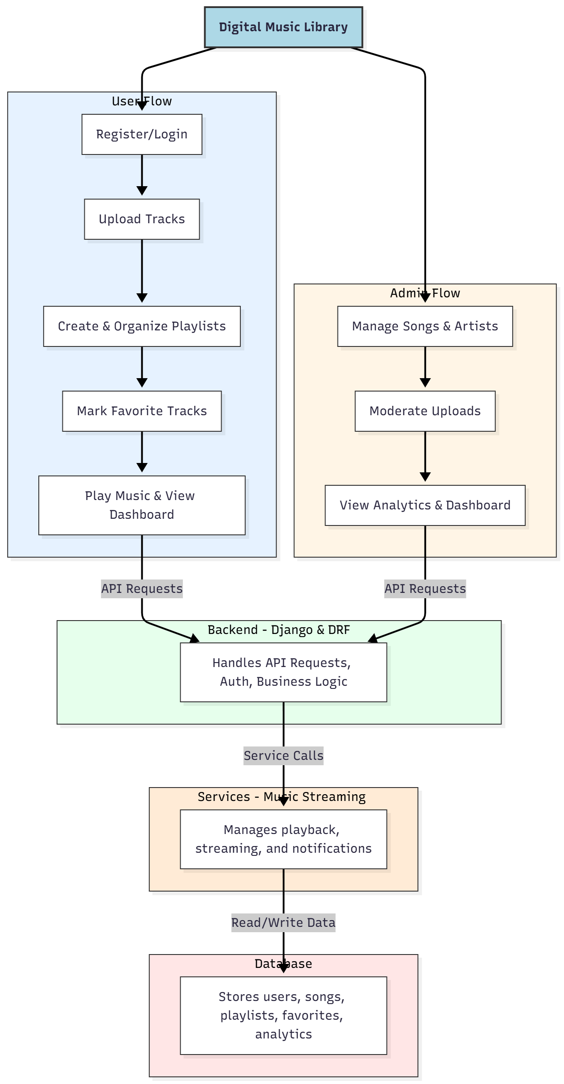

WORKING OF THE PROJECT:
Users register and log in to upload music tracks, create and organize playlists, mark favorites, and play tracks through the platform. Administrators manage songs and artists, moderate uploads, and view analytics dashboards to monitor platform usage. The backend handles authentication, API requests, and business logic, while streaming services ensure smooth playback. All music data, playlists, user preferences, and analytics are stored in a central database for efficient management..

SOFTWARE REQUIREMENT:
- Backend:
  - Python 3.x
  - Django
  - Django REST Framework
  - SQLite/PostgreSQL
- Frontend:
  - Node.js and npm
  - React.js
  - Axios
- Development Tools:
  - Visual Studio Code
  - Postman (for testing APIs)
  - Git/GitHub (for version control)
- Server/Deployment (Optional):
  - Gunicorn, Nginx, or Heroku/AWS for hosting

ADVANTAGES OF THE PROJECT:

• Centralized platform for music uploads and playback
• Playlist creation and organization for users
• Favorite track tracking
• Admin moderation and management of music content
• Analytics dashboards for engagement tracking
• Smooth music streaming experience
• Supports both individual and professional creators
• Enhances music discovery and management

APPLICATIONS OF THE PROJECT:
• Digital music libraries for institutions or communities
• Platforms for musicians to upload and manage tracks
• Personal music management and streaming
• Educational or audio content platforms
• Analytics-driven user engagement platforms
• Playlist management applications
• Music discovery and recommendation platforms
• Integrated dashboards for music content management

REFERENCES:

- Django REST Framework Documentation — Django Software Foundation. Django Documentation. Available: https://docs.djangoproject.com/
- Django REST Framework. DRF Documentation. Available: https://www.django-rest-framework.org/
- React. React Official Documentation. Available: https://reactjs.org/docs/getting-started.html
- Redux. Redux Documentation. Available: https://redux.js.org/introduction/getting-started
- PostgreSQL Global Development Group. PostgreSQL Documentation. Available: https://www.postgresql.org/docs/
- MySQL. MySQL Reference Manual. Available: https://dev.mysql.com/doc/
- Git. Git Documentation. Available: https://git-scm.com/doc
- Node.js. Node.js Documentation. Available: https://nodejs.org/en/docs/
- Axios. Axios Documentation. Available: https://axios-http.com/docs/intro
- Socket.io Documentation – https://socket.io/docs/

